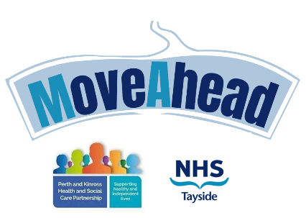

Application for the MoveAhead Workshops
Name: Date of Birth:
Contact Number:
Email Address:
Address:

Emergency Contact
Name: Phone Number:
Do you have any health concerns that we need to be aware of? Yes / No (delete as appropriate)
If so, please provide brief information:

Do you have any trauma that we need to be aware of? Yes / No (delete as appropriate)
If so, please provide brief information:

Please indicate which workshop(s) you wish to attend:
- Anxiety

- Confidence

- Resilience
Our workshops are led by a diverse team of facilitators, including individuals of all genders. While we strive to accommodate your preferences and take your background into account, we cannot guarantee that a specific gender of facilitator will be available for your session. However, please know that all our facilitators are highly trained, professional, and committed to creating a supportive and inclusive environment for all participants. If you have any specific concerns or requirements, we encourage you to reach out to us in advance, and we will do our best to address them.
NHS Tayside has obligations under the Data Protection Act (DPA)(2018) to collect and store your personal information securely. We have requested emergency contact information and details of any health issues for health and safety purposes. This information will not be shared with any third-party organisations. You have the right to withdraw consent at any point the information provided will only be stored for the duration of the workshop.
For more information please visit: http://www.nhstayside.scot.nhs.uk/YourRights/PROD_298457
I have read and understood the above statement. Yes / No

Name:
Signature: Date:

Referrer Details: Name: Contact Number:

Please return this form to: TAY.moveaheadworkshops@nhs.scot
Or alternatively post to; MoveAhead Workshops, Cairnwell, Perth Royal Infirmary, PH1 1NX

MoveAhead Workshops, Cairnwell, Perth Royal Infirmary, PH1 1NX

We put a statement in the form saying that we only use this info to contact them re the group and to make sure we are aware of significant health issues for safety reasons. We say we destroy info after they leave and do not pass info on to third parties. We also say they have the right to withdraw consent at any time and mention about the confidential storage of info by us.

